# Create a world-clock single page, responsive app:

* You have to use Bootstraps grid;
* You have to use AngularJS.
* jQuery should not be used at all.
* Attached are some mockups for Desktop, iPad and iPhone layout.
* **Very important**: the project source code should be pushed to github or bitbucket, using git. Please send us the link to the repository (and the credentials if needed - for private repos).

# Breakpoints:

* phones - less than 768px
* tablets - less than 992px
* desktop - the rest

# The application has two sections:

1. main section to display the clock for the 3 cities(Toronto, London, Sydney)
2. settings section to set the time difference between the 3 cities

Main Section:

* Display Toronto time as per mock design.
* Display London time as per mock design.
* Display Sydney time as per mock design.
* Toronto time will be the time set by the user in the "Toronto time" field. The format is "19:25:36" (hh-mm-ss).
* World clocks will be updated every 5 seconds, based on the Operating System's time.

# Settings Section:

* Contains 2 input fields to set the time difference between a specific city and Toronto, the difference is measured in hours and the format is "+-hh" (where hh is a number from 1 to 23, be it positive or negative).
* This difference should reflect in the city's time display, and will update when Toronto time is updated.

# Use the following tutorials:

* <https://docs.angularjs.org/tutorial/step_01>
* <http://getbootstrap.com/css/>

## Desktop view:

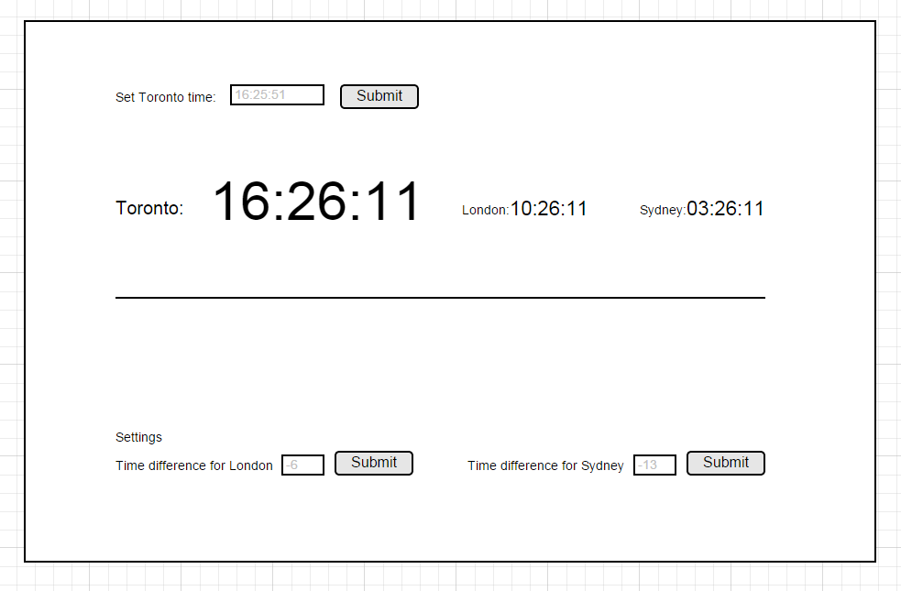

## Tablet view:

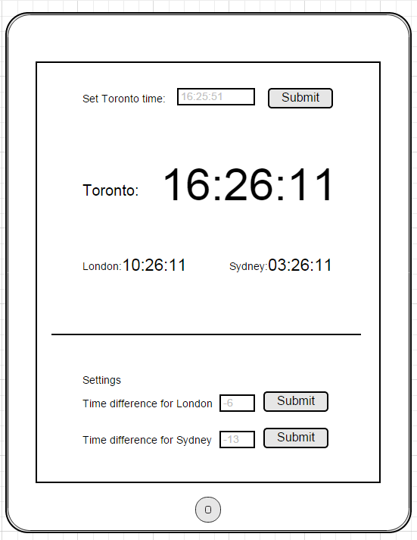

## Phone view:

